User Manual For The Mancala Game

Rules for Mancala
Game Setup:

Players sit opposite each other with the long sides of the gameboard facing them. 6 small pockets on your side of the gameboard belong to you,your large scoring pocket ( mancala ) is to your right.

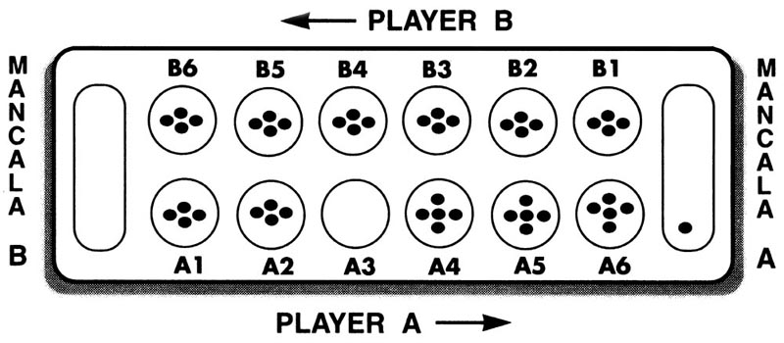

How to Play

- Choose a player to go first and pick up all of the stones from one of your pockets.
- In a counter-clockwise direction,place one piece into each pocket,including your mancala,not your opponent’s mancala.
- If there are enough stones to go past your Mancala, continue placing them into your oppenent's pockets. However, skip his Mancala when placing stones.
- If your last stone ends up in your Mancala, you get to take another turn. In illustration 1, Player A has emptied his #3 pocket and the last stone ended up in his Mancala, allowing him to take another turn.
- If the last stone you place lands in an empty pocket on your side of the board, you get to take that stone -- plus all of your opponent's stones that are in the opposite pocket-- and place them in your own Mancala. As shown in illustration 2, Player B has moved the one stone from his pocket #2 into the empty pocket #3. He would now take that stone and the stones that are in A4 and place all those stones in his Mancala. His turn would then end and the next player goes.
- After you do this and capture,your turn is over.

Capturing your opponent’s stones

- If you place the last stone of your turn into an empty pocket on your side of the board,you capture all of the pieces in the pocket directly across from it on your opponent’s side of the board.
- Take the captured stones and the capturing stone, place them in your mancala.

How to win

As soon as all the small pockets on one side of the gameboard have been emptied,the game is over. The player with the most pieces in his or her mancala wins the game.

Illustration 1
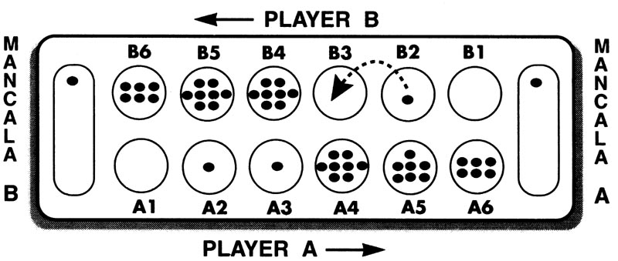

Illustration 2

How to start and play the visual game

1. To run the game,click on the Mancala.jar.

- After you run the Mancala.jar, you will see the game menu on the top left corner and press on it. You will see the New Game and click on it to start the game.
3. The bottom field which is written “ It is Alice's / Bob's turn ” shows that whose turn it is to play at the moment.

4. The buttons with the numbers show the pits with how many stones there are in.

5. The big fields which are on the right and left side with the number “ 0 “ is storage ( Mancala ) for the players.

6. The history which is under the game menu shows the scores and names from the previous games.

7. Exit which is under the game menu will exit the game when you click on it.

8. To play the game, you will see the whose turn it is at the bottom field and according to that, just click one of the buttons which is related to current player's pit to take the stones and the game will distribute the stones automatically. Then, you will see the updated numbers on the game. This means that this is the new situation with the new stones in pits / storage and the next turn will show up at the bottom field.

